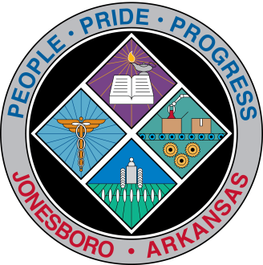
Communications Department
FOR IMMEDIATE RELEASE

Oct. 10, 2016

Contact: Bill Campbell
Director of Communications
870-932-1052 (o), 870-919-7042 (c)
wcampbell@jonesboro.org

JPD received almost $14,000 for bullet-proof vests

The City of Jonesboro has received a grant worth $13,860 to use for the purchase of 35 bullet-proof vests for its police officers over the next year, the U.S. Department of Justice has informed the city.

Each of the city’s 159 officers, plus 25 reserves, is equipped with bullet-proof vests, which are required to be worn when on patrol under JPD policy.

“Though we’ve been blessed in Jonesboro, there’s been an increase in officer deaths around the country over the past five or six years,” Jonesboro Mayor Harold Perrin said. “We’re committed to providing every safety precaution for our officers out in the field, and this just helps defray some of the costs.”

Jonesboro Police Chief Rick Elliott emphasized the importance of the vests, as well as the financial ability to keep officers outfitted in the most state of the art equipment.

“Having safe, up-to-date body armor provides a big layer of protection for the men and women who serve our city,” Elliott said. “This program allows us to change out the armor every five years, which is the manufacturer’s recommended rate. A lot of agencies don’t have the ability to do that.”

The Bureau of Justice Assistance announced the award under the Fiscal Year 2016 Bulletproof Vest Partnership.

###

