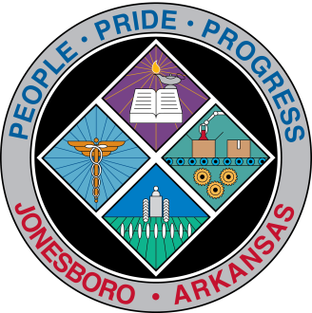
Communications Department
FOR IMMEDIATE RELEASE

Dec. 14, 2016

Contact: Bill Campbell
Director of Communications
870-932-1052 (o), 870-919-7042 (c)
wcampbell@jonesboro.org

Perrin appointed to National League of Cities committee

Jonesboro Mayor Harold Perrin has been reappointed to the National League of Cities 2017 Finance, Administration and Intergovernmental Relations federal advocacy committee.
This committee has the lead responsibility for developing NLC’s federal policy positions on issues involving national economic policy, general financial assistance programs, liability insurance, intergovernmental relations, census, municipal bonds and capital finance, municipal management, antitrust issues, citizen participation and civil rights, labor relations, Native American sovereignty and municipal authority. The appointment was announced Tuesday by NLC President Matt Zone, a Cleveland council member.
As a member of the committee, Perrin will play a key role in shaping NLC’s policy positions and advocate on behalf of America’s cities and towns before Congress, with the new administration and at home. He also will be able to bring the best ideas to Jonesboro.
“This committee is composed of representatives of cities our size and larger, and we discuss ways to be more efficient,” Perrin said. “We discuss best practices, and I’ll get a lot of ideas to create savings for the City of Jonesboro.”
The leadership of this year’s committee will consist of Chair Deverick Williams, council president, Gadsden, Alabama, and Vice Chairs Sue Osborn, mayor, Fenton, Michigan, and John Kinnaird, council member, Waco, Texas.
For more information on NLC’s other committees and councils, go online to www.nlc.org/influence-federal-policy/policy-committees.
###

